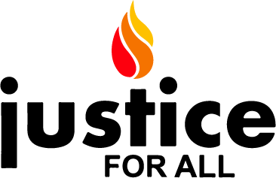

Dear Honorable Congressperson,
Thank you for meeting with us. As constituents we are very concerned with the rise of fascism in India. India erupted in protests over a new law that is a convoluted way to revoke citizenship from people of the land, based on their faith. This new law would allow Indian residents of any religion who cannot prove their citizenship to become Indian citizens, except Muslims. Disregarding the Indian constitution, the fascist RSS/BJP/Modi government has pushed it through the system.

This unjust measure has been applied already to the Indian state of Assam. In that application, 1.9 million Bangla-speaking people were stripped of their citizenship. Just after that, India re-invaded Kashmir in August, restricting movement, access to services, and complete Internet and communications shutdown. India tops the world in terms of internet blackouts, and is the only country which is under two genocide alerts by the respected organization Genocide Watch. Early warning signs indicate that a genocidal process is underway. Before India commits genocide on a section of its own people, we urge you to consider the following steps:
- Release a statement expressing concern on rising facism in India.
- Write a letter to the Sec. of State asking him to convey to the Indians that the brutal repression of protests be stopped immediately, internet blockades be lifted. India should be declared a top tiered country of violating religious liberties of minorities.
- Introduce a resolution asking that the RSS, and its American front non-profit organizations be thoroughly investigated and be declared as extremist & terrorist organizations.
- Write to the Indian Ambassador saying you do not appreciate their trying to keep Rep. Pramila Jayapal out of meetings, and fully support her.
We appreciate the work that you have put into furthering Human Rights issues in different parts of the world and in the United States. We believe that, as Americans, we have a moral obligation to influence and encourage other countries using all means that are available to us. A peaceful world should be the concern of us all.
Sincerely,

Brief Summary on the Situation in India

India is witnessing a massive amount of protests, mostly by students who are protesting against the passage of the Citizenship Amendment Act (CAA). The police responded with force against peaceful protestors, especially at the Jamia Millia Islamia (JMI) and the Aligarh Muslim University (AMU), leaving many injured and unfortunately, some students have been killed. Students from many Indian universities have joined protests against the CAA, and in solidarity with JMI & AMU. Protestors are from all religious communities, including the majority Hindu as well as the minority Muslim, Sikh, Christian and Dalit communities.

The BJP govt. Of Narendra Modi, and its satellite BJP govts. In several states have tried to (1) give the protests a religious angle, and (2) suppress the protests altogether, using (ironically) a colonial era anti-civil-disobedience law (section 144). The Internet has now been shut down in several areas. The Indian Govt. regularly uses shutdown tactics hoping to stifle opposition, and to suppress popular reporting using social media.

https://www.newsweek.com/indias-immigration-protests-are-morphing-resistance-modis-hindu-nationalist-rule-1478747

https://www.indiatoday.in/india/story/anti-caa-protests-singe-up-leave-15-dead-internet-suspended-in-jaipur-prayagraj-1630440-2019-12-22

Background on the new Citizenship Amendment Act

The Modi/RSS govt. would like India and the world to believe that the CAA is a very humanitarian bill which will allow India to provide refuge and citizenship to victims of religious persecution from Pakistan, Afghanistan & Bangladesh. It however discriminates on the basis of religion, since it excludes Muslims from obtaining citizenship via this route. This is in direct violation of the Indian constitution, its pre-amble as well as article 14 of the Indian constitution.

India is also planning on implementing what it calls the National Registry of Citizens (NRC). The NRC process puts the onus on the citizen to prove their own citizenship, and old documents would be needed. India has many who do not have stable housing, are illiterate, and these would be very severely affected by the process since it would be difficult for them to produce documentary proof. The NRC has already been implemented in Assam with the results that many Hindus were also found to be non-Citizens. The govt. has plans to change India into a Hindu nation and the largest minority of Muslims, poses what it sees as a threat to that declaration. The NRC would have many non-Muslims declared as non-citizens. Thus a mechanism was needed in-order to filter out Muslims from non-Muslims. In combination with the CAA, a mechanism will be in place to re-grant Hindus, Sikh, Christians, Buddhist, Parsis & Jains with citizenship, while leaving Muslims, Jews, Atheists etc. as non-citizens. The flowchart below, is considered to be an accurate representation of the core of the NRC+CAA combine. It does not show the time stipulations of the act for simplicity.

The NRC+CAA combine is not unlike the Nurenburg laws of Nazi Germany, which were designed to separate Germanic peoples from Jews and other minorities, and create conditions of legal discrimination. We know where that led Germany. To the holocaust, and the subsequent declaration of “Never Again” by the world community. India has already built detention centers in the states of Assam and at least one reported in the southern (BJP led) state of Karnataka.

https://www.indiatoday.in/india-today-insight/story/everything-you-wanted-to-know-about-the-caa-and-nrc-1630771-2019-12-23

https://economictimes.indiatimes.com/news/et-explains/citizenship-amendment-bill-what-does-it-do-and-why-is-it-seen-as-a-problem/articleshow/72436995.cms?from=mdr

https://twitter.com/thewire_in/status/1207609839959998464

https://www.vox.com/future-perfect/2019/9/17/20861427/india-assam-citizenship-muslim-detention-camps

https://indianexpress.com/article/india/detention-centre-for-illegal-immigrants-near-bengaluru-gets-finishing-touches-6180274/

Background on the RSS and activities in the USA

The RSS was established by a physician by the name of Hedgewar, but subsequent leaders such as Golwarkar and Savarkar drew inspiration from Nazi Germany and openly declared that the Nazi model was a good one for Indian Hindus to adopt. While not against Jewish people, RSS leaders considered the largest minority of India, the Muslims, as the community to target using methods similar to what the Nazis used against Jewish people.

In the United States there are several organizations such as the Hindu Swayamsevak Sangh (HSS) that implement the same training methods that the RSS does. Other organizations such as the Hindu American Foundation (HAF) have provided political support to the RSS by allowing its leader, Mohan Bhagwat to address their 2018 convention.

https://en.wikipedia.org/wiki/Rashtriya_Swayamsevak_Sangh

https://religionnews.com/2018/09/10/world-hindu-congress-draws-crowd-protest-on-anniversary-of-speech-that-put-religion-on-map/
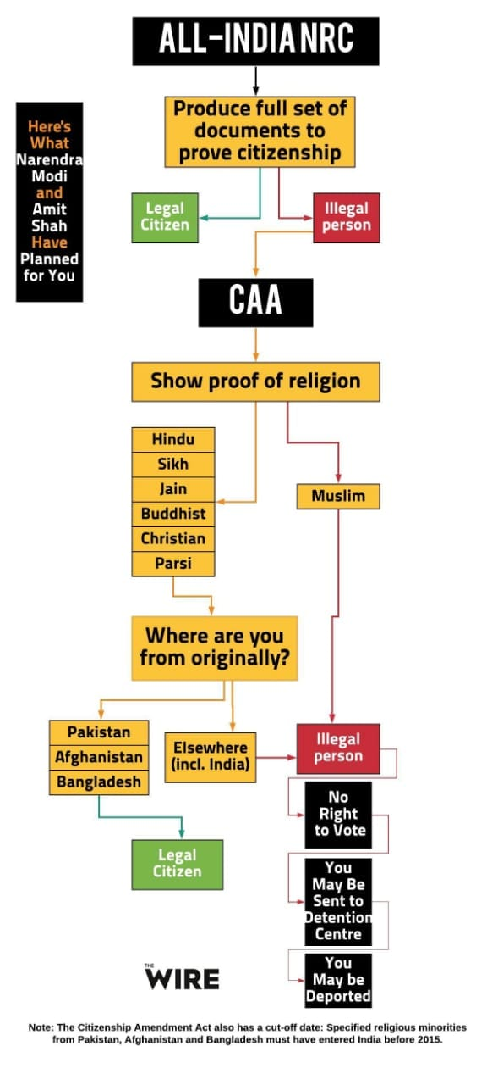
Note: In addition to Muslims, those who are Jews, Atheists etc. would also not be granted Indian citizenship.

