01/07/2020

(This file is on the included flash disk, with the related supporting report and video files.)

Some instances of unprovoked attacks on students/protestors:

Perhaps the most telling video that was taken was of the girls protecting their male friend. He had been pulled out by police and was beaten. The girls came to his protection. These girls became the defining image for the protests in India.
File: GirlsDefiningResistance.mp4

Some instances of police atrocities are below. This is a sample, but many such instances have been collected and are being documented at this time by Indian organizations. We can provide instances in addition to the below.

1) Jamia Millia Islamia:
The Jamia Millia Islamia (JMI) is in the capital city of India, Delhi. JMI students were amongst the first to protest the passage of the Citizenship Amendment Act. The protests were peaceful. After the conclusion of the protests, as students were studying at the university library, Delhi police fired tear gas shells into the enclosed library space, a violation of international law.
https://www.theguardian.com/world/video/2019/dec/17/police-fire-teargas-inside-university-library-during-india-citizenship-protests-video

Police also fired gas shells on a students’ march
Outlook India report: https://www.youtube.com/watch?v=CGLxIgnkYIg

2) Aligarh Muslim University:
Police forcibly entered the campus which has clearly defined boundaries. Shells were fired on protesting students. The police claimed that students began attacking them by pelting rocks. This was then refuted by a fact-finding team that reached Aligarh the next day. It found that police had overnight cleaned up any evidence of firings. Several students are still missing.
https://www.indiatoday.in/india/story/amu-protests-fact-finding-team-1629215-2019-12-18

Independent report:
File: FactFindingReport–AMU.pdf

3) Jawaharlal Nehru University:
Just over the last couple of days, JNU teachers and students opposed to the CAA and NRC have come under attack by what has been determined as mobs of the RSS youth wing (abbreviated as ABVP). The police has allowed such mobs to run rampant and has not been stopping them, turning a blind eye to the carnage.
https://www.facebook.com/ndtv/videos/2520903794703685/?v=2520903794703685

There have been several injuries, including that of a student leader. Police filed a case against her, although she was the victim.
https://www.thehindu.com/news/cities/Delhi/bandaged-jnusu-president-recounts-mob-attack/article30498104.ece?utm_source=vuukle&utm_medium=talk_of_town
https://www.aljazeera.com/news/2020/01/jnu-attack-police-file-fir-injured-student-union-leader-200107070940222.html
https://time.com/5760593/jnu-attack-student-protests/

A right wing group (The Hindu Rashtra Dal) claims responsibility, but yet no arrests have been made by the Delhi police.
https://www.thequint.com/news/india/hindu-rashtra-dal-bhupendra-tomar-pinky-bhaiyya-takes-responsibility-for-jnu-attack

4) Police have been part of the problem, and are destroying property

Police standing by as a mob sets fire to a Muslim owned sawmill
https://www.facebook.com/watch/?v=550602902460769

Kanpur, Police stand by as people pelt stones on presumably the protesters opposing the CAA.
File: Kanpur-PoliceStandbyStoning.mp4

Town of Aurangabad, Bihar police destroying property
File: BiharPoliceDestroyingProperty.mp4

Police entering homes of Muslims without reason or warrants, and destroying property
File: PoliceDestroyedInsideUPHome.mp4

In Uttar Pradesh, the town of Muzaffarnagar has seen targeted and unprovoked attacks by police on Muslims
https://www.indiatoday.in/india/story/every-assailant-was-policeman-activists-accuse-up-police-of-assaulting-muslims-caa-stir-release-videos-1632361-2019-12-29

In addition many other towns in Uttar Pradesh, including the capital Lucknow have seen mass arrests and beatings of unarmed protestors by police.
https://www.washingtonpost.com/opinions/2020/01/03/repression-india-gets-worse-notable-figures-remain-silent/

5) Police have been detaining without reason, beating people who are not armed, or even those who have given up resisting. Some examples are below and we can provide many more such examples

File: PickingUpOlderPeople.mp4
The old man is being led into a police vehicle, while a woman pleads with them to let him go. The police answer they are only getting him some tea, but the reluctance of the man in entering the vehicle is very evident.

File: BeatingUnnecessarily.mp4
File: PoliceBeatingManwithHandsUp.mp4

6) Members of the RSS have been seen having donned police uniforms and patrolling as though they are part of the police.

File: BJPDressedPoliceNoNameBadge.mp4
These are RSS members, having donned on police uniforms but without badges. The identity of the lead was determined to be a RSS/BJP member, Ashok Dogra Bundi.
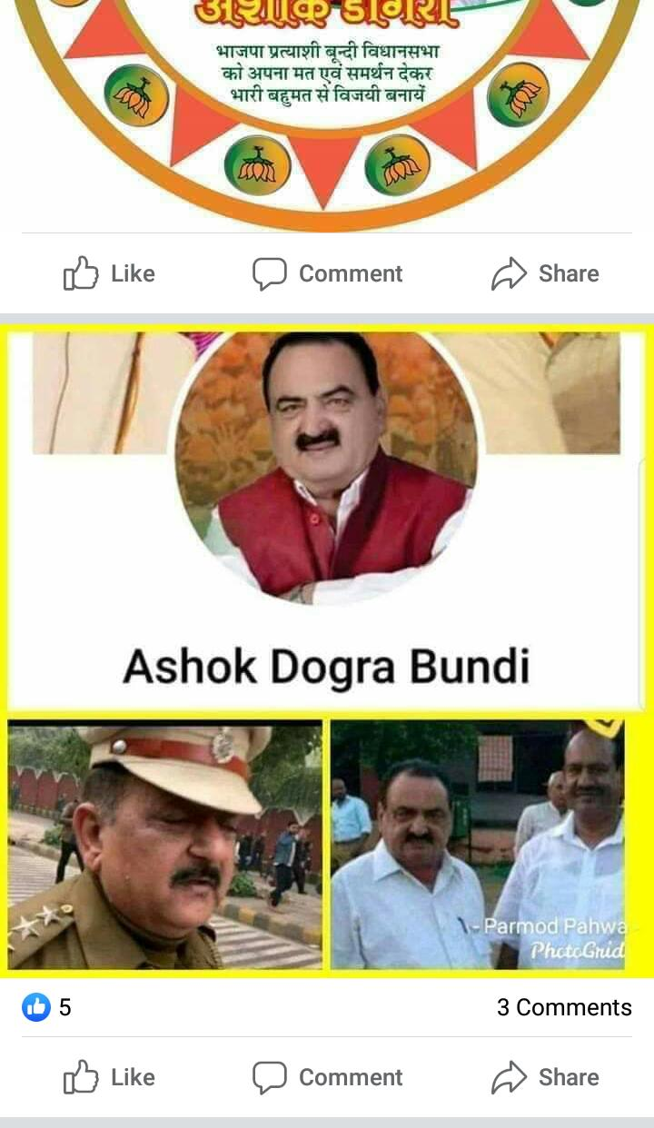
Another instance was a group of RSS/BJP members dressed in what would be recognizable as Muslims, throwing stones at a passing train.
https://www.news18.com/news/politics/reports-of-bjp-supporters-changing-clothes-to-attack-train-in-murshidabad-true-says-mamata-banerjee-2431151.html
https://thewire.in/communalism/murshidabad-bjp-lungi-skullcap

