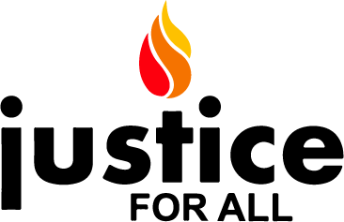

The Honorable Congressperson,
Thank you for meeting with us. As constituents we are very concerned with the rise of fascism in India. India has erupted in protests over a new law that is a convoluted way to revoke citizenship from people of the land, based on their faith. This new law would allow residents, currently in India, of any religion who cannot prove their citizenship, to become Indian citizens, except for Muslims. Disregarding the Indian constitution, the fascist RSS/BJP/Modi government has pushed it through the system. The Citizenship Amendment Act of 2019, when combined with the National Register of Citizens, provides a legal framework for stripping Muslims in India of their citizenship.

A series of actions using a legal background targeting Muslims & other minorities:
India has taken several steps to suppress its Muslim population, the 2nd largest in the world. In 2018-19, we have seen the following:
- 1.9 million Bangla-speaking people were stripped of citizenship after the application of the National Citizens Register
- India invaded Kashmir on August 5, restricting movement, access to services, and complete Internet and communications shutdown.
- The Babri Mosque in Ayodhya India, which was demolished by a mob of RSS members in 1992 was handed over to the same mob by the Supreme Court of India. While the court held that entering the mosque was illegal, as was its demolishing, it handed over the rights to the land solely on the basis of faith. This is a result of deterioration of the Indian judicial system.
- The Citizenship Amendment Act, which is the reason we are meeting with you today.

In addition, there are several instances of mob violence against minority communities, including Sikh, Dalit, Christian & Muslim sections of Indian society.

India tops the world in terms of internet blackouts, and is the only country which is under two genocide alerts by Genocide Watch. Early warning signs indicate that a genocidal process is underway. The stripping of citizenship may just be the beginning of a legal framework towards that goal.

The RSS, which has openly called to keep minorities as second class citizens in the country, and which is the backbone of the Modi government, has several non-profit fronts in the United States. These include:
The Hindu Swayamsevak Sangh, America (HSS)
Ekal Vidyalaya America, a system of indoctrination schools in India
The Vishwa Hindu Parishad, America (VHP)

We at Justice For All, recognized the signs of genocide in Burma against the Rohingya and had called for it to be stopped early. That did not happen, but we ask that before India commits genocide on a segment of its own people, please consider the following steps:

- Release a statement recognizing India, under Prime Minister Modi’s governance, is under fascism.

- Write a letter to the Sec. of State, the honorable Mike Pompeo asking him:
  - To convey to the Indians that the brutal repression of protests be stopped immediately, internet blockades be lifted.
  - That India be declared a Tier 1 country of religious repression of minorities
  - To investigate fully the funding sources of the RSS from its front nonprofits based in the US, and their use for indoctrination and hate.
  - An investigation of Yogi Adityanath, the Chief Minister of the state of Uttar Pradesh, his involvement in unprovoked attacks by police forces on innocent civilians and damage to civilian property, and a recommendation that Global Magnitsky sanctions be placed against him if found to be so.

- Introduce a resolution asking that the RSS, and its American front nonprofit organizations be thoroughly investigated and declared as extremist & terrorist organizations.

- Write to the Indian Ambassador expressing your dismay on the exclusion of Rep. Pramila Jayapal from crucial meetings, and your full support of her.
- Recommend that the Foreign Relations committee send a fact-finding team to India and Kashmir with a further recommendation that until India allows such a mission, free and unfettered access, any trade negotiations with India be put on hold.
We appreciate the work that you have done into furthering Human Rights issues in different parts of the world and in the United States. We believe that, as Americans, we have a moral obligation to influence and encourage other countries using all means that are available to us. A peaceful world should be the concern of us all.
Sincerely,

References:
Kashmir: https://www.usatoday.com/story/news/world/2019/08/06/indian-troops-invade-kashmir-pakistan-warned-war/1939894001/

Babri verdict: https://www.washingtonpost.com/opinions/2019/11/11/indias-supreme-court-endorses-right-wing-vision-relegating-muslims-second-class-citizens/

Sikh/Christian attacks: https://sikhsiyasat.net/2020/01/05/nankana-sahib-incident-statement-of-bc-gurdwaras-council-and-ontario-gurdwaras-committee/?fbclid=IwAR2AHfhMP4gW_fP7WSvphh5U-a0i2ciMbl21BbjAACu0RB8-sgH7u3ScQw8
https://www.deshabhimani.com/english/news/national/rss-men-hurl-bombs-at-church-shouting-jai-shri-ram-3-arrested-west-bengal/1405

USCIRF/American Academy of Religion reports and recommendations on the NRC/CAA:
https://www.uscirf.gov/sites/default/files/2019%20India%20Issue%20Brief%20-%20Religious%20Freedom%20Implications.pdf
https://www.aarweb.org/a-statement-on-the-situation-in-india-in-the-wake-of-the-citizen-amendment-act?q=a-statement-on-the-situation-in-india-in-the-wake-of-the-citizen-amendment-act
https://www.uscirf.gov/news-room/press-releases-statements/uscirf-raises-serious-concerns-and-eyes-sanctions

A brief summary on the situation in India

India is witnessing a massive amount of protests, mostly by students who are protesting against the passage of the Citizenship Amendment Act (CAA). The police responded with force against peaceful protestors, especially at the Jamia Millia Islamia (JMI) and the Aligarh Muslim University (AMU), leaving many injured and unfortunately, some students have been killed. Students from many Indian universities have joined protests against the CAA, and in solidarity with JMI & AMU. Protestors are from all religious communities, including the majority Hindu as well as the minority Muslim, Sikh, Christian and Dalit communities.

The BJP govt. Of Narendra Modi, and its satellite BJP govts. In several states have tried to (1) give the protests a religious angle, and (2) suppress the protests altogether, using, ironically, a colonial era anti-civil-disobedience law (section 144). The Internet was shut down in several areas, with sporadic openings. The Indian Govt. regularly uses shutdown tactics hoping to stifle opposition, and to suppress popular reporting using social media.

https://www.newsweek.com/indias-immigration-protests-are-morphing-resistance-modis-hindu-nationalist-rule-1478747

https://www.indiatoday.in/india/story/anti-caa-protests-singe-up-leave-15-dead-internet-suspended-in-jaipur-prayagraj-1630440-2019-12-22

Background on the new Citizenship Amendment Act

The Modi/RSS govt. would like India and the world to believe that the CAA is a very humanitarian bill which will allow India to provide refuge and citizenship to victims of religious persecution from Pakistan, Afghanistan & Bangladesh. It however discriminates on the basis of religion, since it excludes Muslims from obtaining citizenship via this route. This is in direct violation of the Indian constitution, its pre-amble as well as article 14 of the Indian constitution. Furthermore, Indian law did allow for citizenship to be granted, but without a religious filter. This amendment was not necessary as being claimed by the Modi regime. We believe that the amendment was made, specifically so Muslims can be excluded from citizenship consideration.

India is also planning on implementing what it calls the National Registry of Citizens (NRC). The NRC process puts the onus on the citizen to prove their own citizenship, and old documents would be needed, as we have seen in the case of the state of Assam, where the NRC was implemented already. A passport, voter registration, id card etc. were not cosidered as sufficient documentation for citizenship. India has many who do not have stable housing, are illiterate, and these would be very severely affected by the process since it would be difficult for them to produce documentary proof. The NRC when implemented in Assam resulted in many Hindus deemed to be non-Citizens. The RSS backed govt. has plans to change India into a Hindu nation and the largest minority of Muslims, poses what it sees as a threat to that declaration. Since the NRC would have many non-Muslims declared as non-citizens, a mechanism was needed in-order to filter out Muslims from non-Muslims. The CAA allows just that. A mechanism will now be in place to re-grant Hindus, Sikh, Christians, Buddhist, Parsis & Jains with citizenship, while leaving Muslims, Jews, Atheists etc. as non-citizens. The flowchart below, is considered to be an accurate representation of the core of the NRC+CAA combine. It does not show the time stipulations of the act for simplicity.

The NRC+CAA combine is not unlike the Nurenburg laws of Nazi Germany, which were designed to separate Germanic peoples from Jews and other minorities, and create conditions of legal discrimination. We know where that led Germany. To the holocaust, and the subsequent declaration of “Never Again” by the world community. India has already built detention centers in the states of Assam and at least one reported in the southern (BJP led) state of Karnataka.

https://www.indiatoday.in/india-today-insight/story/everything-you-wanted-to-know-about-the-caa-and-nrc-1630771-2019-12-23

https://economictimes.indiatimes.com/news/et-explains/citizenship-amendment-bill-what-does-it-do-and-why-is-it-seen-as-a-problem/articleshow/72436995.cms?from=mdr

https://twitter.com/thewire_in/status/1207609839959998464

https://www.vox.com/future-perfect/2019/9/17/20861427/india-assam-citizenship-muslim-detention-camps

https://indianexpress.com/article/india/detention-centre-for-illegal-immigrants-near-bengaluru-gets-finishing-touches-6180274/

Background on the RSS and activities in the USA

The RSS was established by a physician by the name of Hedgewar, but subsequent leaders such as Golwarkar and Savarkar drew inspiration from Nazi Germany and openly declared that the Nazi model was a good one for Indian Hindus to adopt. RSS leaders considered the largest minority of India, the Muslims, as the community to target using methods similar to what the Nazis used against Jewish people.

In the United States there are several organizations such as the Hindu Swayamsevak Sangh (HSS) that implement the same training methods that the RSS does. Other organizations such as the Hindu American Foundation (HAF) have provided political support to the RSS by allowing its leader, Mohan Bhagwat to address their 2018 convention.

https://en.wikipedia.org/wiki/Rashtriya_Swayamsevak_Sangh

https://religionnews.com/2018/09/10/world-hindu-congress-draws-crowd-protest-on-anniversary-of-speech-that-put-religion-on-map/

Golwalkar’s quote on Nazi methodology:
“...To keep up the purity of the nation and its culture, Germany shocked the world by her purging the country of Semitic races – the Jews. National pride at its highest has been manifested here. Germany has also shown how well-nigh impossible it is for races and cultures, having differences going to the root, to be assimilated into one united whole, a good lesson for us in Hindustan to learn and profit by,” (Bunch of Thoughts and We, or Our Nationhood Defined.)

NRC/CAA flowchart:
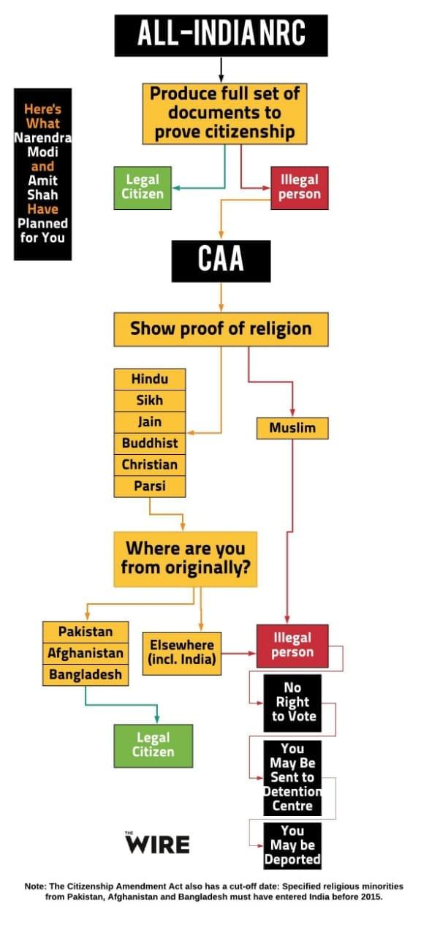

In addition to Muslims, those who are Jews, Atheists etc. would also NOT be granted Indian citizenship.

